 

**INTERNSHIP REPORT**

March 10th 2025 – April 8th 2025

**Submitted to:**

**Submitted by:**

Intern,

NCRP, I4C MHA

**Acknowledgment**

I extend my deepest gratitude to the esteemed leadership and mentors at the **Indian Cyber Crime Coordination Centre (I4C), Ministry of Home Affairs**, for their invaluable guidance and unwavering support throughout my internship. Their mentorship has played a pivotal role in broadening my knowledge, refining my technical skills, and enhancing my professional growth. The enriching experience I have gained during this internship would not have been possible without their continuous encouragement and insightful advice.

I wish to express my profound appreciation to **Sh. Rajesh Kumar, CEO of I4C**, for his visionary leadership and for fostering an environment that promotes learning, innovation, and excellence. His commitment to advancing cybercrime prevention and cybersecurity initiatives has been truly inspiring and has provided me with an exceptional platform to gain practical insights into the field.

I am deeply grateful to **Sh. Manish Garg, Director (NCRP),** for his steadfast support and invaluable guidance. His expertise and leadership have been instrumental in broadening my understanding of cybersecurity frameworks and best practices. His insightful direction has enabled me to develop a structured and analytical approach to addressing cybersecurity challenges effectively

I also extend my sincere appreciation to **Sh. Vishal Dhiman, Deputy Director (NCRP),** for his unwavering support and mentorship. His profound knowledge and guidance have played a crucial role in enhancing my technical acumen and problem-solving skills in the field of cybersecurity. His encouragement and expert advice have been invaluable in helping me navigate complex security concepts and real-world applications.

I extend my sincere gratitude to **Pawan Singh** for their invaluable guidance throughout my training in web development. His mentorship played a crucial role in enhancing my technical skills and understanding of real-world applications. His patience, encouragement, and expertise made the learning experience both enriching and enjoyable. I am truly thankful for the knowledge and confidence I gained under his guidance.

Lastly, I would like to express my appreciation to all my colleagues, peers, and team members at I4C for their support, collaboration, and encouragement. The knowledge and experience I have gained during this internship have been truly invaluable, and I will carry these learnings forward in my professional endeavors.

This internship has been an immensely enriching experience, and I am deeply grateful for the

opportunity to work with such a distinguished team of professionals. I look forward to applying the insights I have gained here in my future career and contributing meaningfully to the field of cybersecurity.

**Table of Contents**

PREFACE 4

EXECUTIVE SUMMARY 4

INTRODUCTION 5

BACKGROUND AND INTERNSHIP 5

OBJECTIVES OF THE INTERNSHIP 5

BRIEF OVERVIEW 6

MAIN BODY 7

1. Roles and Responsibilities 7

1.1 Understanding the NCRP Portal 7

1.2 Enhancing the efficiency of the NCRP Portal : Challenges and solutios 8

1.3 Tasks Assigned 9

1.3.1 Suspect Registry Dashboar……………………………………………………

1.3.1.1 Analysed the provided maked excel data, Unmasking and preprocessing the data………………………………………………………………………………………..10

1.3.1.2 Designed basic famework of dasboard with the provided graphs summary 11

1.3.1.3 Developed Unique Field Analysis for key Attributes………………………….

1.3.1.4 Built Visual Insights of Records by bank and source………………………………

1.3.1.5 Integrated Date Filtering and Top Contributor Detection…………………………….

1.3.1.6 Final Dashboard Styling, Optimization, and Testing…………………………………

1.3.2 Database Search System

1.3.2.1 Database creation and Management 13

1.3.2.2 CSV Data Import and Integration with SQLite 15

1.3.2.3 Search System Implementation(GUI) 17

1.3.2.4 Dynamic Query Filtering 20

1.3.2.5 Result Count and Feedback Display 22

1.3.2.6 CSV Export of Filtered Results 23

1.3.2.7 Backend Error Handling and Optimization 24

1.3.2.8 GUI Design and User Experience (UX)……………………………………………….

2. Learning Outcome 25

3. Tools and Technologies Used: 26

4. Challenges Faced: 27

5. Contributions: 28

CONCLUSION: 29

**Preface**

**Executive Summary**

The internship at the Indian Cyber Crime Coordination Centre (I4C), Ministry of Home Affairs (MHA), offered a transformative experience in the field of development. It provided me with a platform to apply my web development skills to real-world security initiatives, enhancing both functionality and user experience in critical systems. This hands-on exposure enabled me to bridge the gap between classroom learning and practical implementation. I contributed to dynamic web interfaces and backend integration, playing a meaningful role in ongoing projects. Being part of such a structured and high-impact environment deepened my understanding of development within the security initiatives led by I4C, MHA.

Throughout my tenure, I actively contributed to significant projects that enhanced both functionality and security. One of my key contributions was developing an interactive dashboard on bank data using Streamlit, which provided intuitive data visualization and real-time insights for analysis. I also worked on identifying and addressing security flaws in the existing National Cybercrime Reporting Portal (NCRP), helping improve its robustness and reliability. These tasks allowed me to apply both my development and cybersecurity knowledge in practical scenarios. Overall, these experiences enriched my technical skillset and deepened my understanding of secure web application development.

Being part of a prestigious cybersecurity organization offered me firsthand exposure to the development domain in a high-stakes, real-world environment. I worked on real-time projects that demanded both technical precision and creative problem-solving. This experience significantly strengthened my skills in secure software development. It also helped me develop a proactive mindset essential for cybersecurity professionals. Overall, the internship laid a strong foundation for my future in both cybersecurity and web development.

Overall, this internship was an enriching and transformative journey that equipped me with both technical proficiency and professional discipline. The exposure to real-world development scenarios and hands-on experience in web development significantly enhanced my practical skills. Guided by expert mentorship, I deepened my understanding and reaffirmed my commitment to the field of secure software and web application development. This experience has provided a solid foundation for my future career in the domains of cybersecurity and full-stack development.

**Introduction**

**Background of the Internship**

As a final-year undergraduate student at Rashtriya Raksha University, I have always been driven by a strong curiosity and passion for the development field. While I have worked on several academic projects and conducted independent research, I wanted to gain real-world, hands-on experience in a high-impact development environment. To bridge this gap, I pursued an internship at the Indian Cyber Crime Coordination Centre (I4C), Ministry of Home Affairs (MHA), India, where I worked as a development intern.

Given the ever-evolving landscape of technology and development, I4C plays a pivotal role in supporting national cybersecurity efforts through innovative digital solutions. Working in such a prestigious and structured organization allowed me to apply my academic knowledge to practical challenges. I had the opportunity to work on real-time projects that required both technical skill and creative thinking. This internship provided me with invaluable insights into the development process within a government cybersecurity agency. It exposed me to structured work culture, teamwork, and collaborative problem-solving. I also learned how critical decision-making processes take place in high-stakes environments. These experiences helped me sharpen my technical skills, improve my communication, and adapt to real-world expectations. Overall, the internship has played a key role in shaping my strategic approach to development and has provided a strong foundation for my future career in this field.

**Objectives of the Internship**

Work on real-time development projects, build dynamic web applications, and apply hands-on skills in front-end, back-end, and database integration.

**Enhance Technical** Strengthen expertise in Angular, Streamlit, RESTful APIs, and secure web development, applying these skills to practical development challenges.

**Develop an Industry-ready Skill Set** – Learn and implement best practices, coding standards, and development methodologies followed by professionals in national-level development projects.

**Understand Professional Workflows** – Gain insights into structured software development life cycles (SDLC), project management tools, and agile-based workflows in a government agency setting.

**Refine Problem-solving & Analytical Thinking** – Debug complex code, optimize application performance, and design efficient, user-friendly web interfaces.

**Contribute to Real-world Development Projects** – Assist in building interactive dashboards, automating processes, and improving the functionality and security of government platforms.

**Expand Professional Network** – Connect with experienced developers, project leads, and technical mentors to enhance domain knowledge and career prospects.

**Strengthen UI/UX and Frontend Skills** – Work on designing clean, responsive interfaces and improving user experience through modern frameworks and styling tools.

**Build Scalable Backend Systems** – Develop and integrate secure, scalable backend systems using Python, SQLite, and API-based communication.

This internship served as a crucial milestone in my journey toward building a career in software development and web technologies, significantly enhancing both my technical expertise and professional growth.

**Brief Overview**

**History**

The Indian Cyber Crime Coordination Centre (I4C) was conceptualized by the Ministry of Home Affairs (MHA), Government of India, to tackle the growing challenges of cybercrime in an increasingly digital world. Approved in October 2018, I4C was officially launched in January 2020 in New Delhi as a centralized framework to coordinate efforts between law enforcement agencies, state governments, and other stakeholders to combat cyber threats effectively.

**Mission**

I4C’s mission is to act as India’s nodal agency for addressing cybercrime by ensuring a coordinated, technology-driven, and proactive approach. It aims to prevent, detect, and investigate cyber-related offenses, equip law enforcement agencies with the necessary tools and training, and foster collaboration between public and private sector stakeholders to strengthen India’s cybersecurity infrastructure.

**Vision**

The vision of I4C is to establish a secure and resilient cyberspace that protects citizens, businesses, and government institutions from cyber threats. By leveraging advanced technologies, strategic partnerships, and policy frameworks, I4C aspires to create a trustworthy digital environment that supports innovation, economic growth, and national security.

**Core Business & Functions**

I4C operates through seven key verticals, ensuring a multi-pronged approach to cybercrime prevention and response:

National Cyber Crime Threat Analytics Unit (TAU) – Monitors, analyzes, and provides actionable intelligence on cyber threats.

National Cyber Crime Reporting Portal – A platform for citizens to report cybercrime incidents online.

National Cyber Crime Training Centre – Enhances the capabilities of law enforcement officers through specialized training in cybersecurity and digital forensics.

Cyber Crime Ecosystem Management Unit – Coordinates and strengthens the cybercrime response framework across the country.

National Cyber Crime Research & Innovation Centre – Promotes research and development of new tools, strategies, and policies to counter cyber threats.

National Cyber Crime Forensic Laboratory (NCFL) Ecosystem – Provides forensic support to aid cybercrime investigations and evidence collection.

Platform for Joint Cyber Crime Investigation Teams – Facilitates collaborative investigations among various law enforcement agencies for complex cybercrime cases.

I4C plays a pivotal role in safeguarding India’s digital ecosystem by implementing a structured and technology-driven approach to cybercrime, ensuring better preparedness against emerging cyber threats at both national and international levels.

# **MAIN BODY**

# **Roles and Responsibilities**

## **1.1 Understanding the NCRP Portal:**

* **Task:** Analysis of complaints from the NCRP portal
* **Implementation**:
* Identified various types of complaints registered on the portal.
* Classified complaints into different types (Financial Frauds, Cryptocurrency Frauds, APK-Related Frauds)
* **Outcome**: Gained insights into the workflow of the NCRP portal, including how complaints are registered, categorized, and processed. Identified different types of cybercrimes reported, such as financial frauds, cryptocurrency scams, defamation.

**1.2 Enhancing the efficiency of the NCRP Portal: Challenges and solutions:**

* **Task:** Identify key inefficiencies and user challenges within the NCRP Portal to propose potential enhancements for improved usability and data management.
* **Implementation:**
* Analysed portal features and user feedback to identify major issues, such as complexity in complaint registration due to legal terminology, lack of supporting documentation, and language barriers.
* Noted inefficiencies in handling suspect registry data, particularly when managing large Excel files.
* Evaluated limitations of current data querying methods and explored the use of SQL on Excel for better data integrity and performance.
* Suggested potential improvements, including:

Integration of an AI-powered chatbot to guide users through the complaint process. Implementation of email verification for user validation

Launching awareness campaigns to educate users about the portal’s functionalities and requirements

* **Outcome:**

Compiled a comprehensive list of challenges and proposed solutions to be considered for future enhancements.Provided a foundation for technical teams to plan improvements aimed at boosting user accessibility, data efficiency, and overall portal effectiveness.

**1.3 Tasks Assigned:**

**1.3.1 Design a dashboard of Suspect Registry and UI Development**

* **Task:** Create an interactive, user-friendly dashboard to visualize and analyse suspect data records, supporting law enforcement or regulatory oversight.
* **Screenshot:**

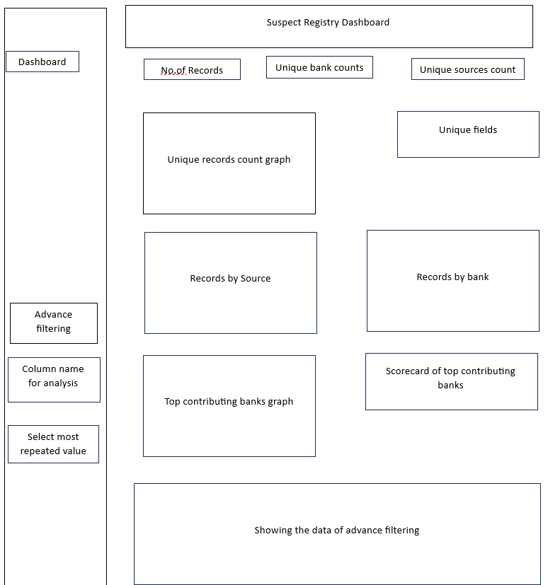

**1.3.1.1 Analysed the provided masked excel data, Unmasking and Preprocessing the**

**data:**

* **Task:** To analyse masked Excel data related to suspected fraudulent accounts, unmask it for investigation purposes, and preprocess it for improved clarity, usability, and integration into downstream processes.
* **Implementation:**
* Examined the masked dataset, which contained obscured fields such as account numbers, PAN numbers, names, email addresses, and phone numbers.
* Identified critical fields that were incomplete or anonymized, hindering effective investigation and correlation.
* Used original data sources to retrieve the full values of the masked fields, including account numbers, CIN numbers, PAN details, and email addresses.
* Performed preprocessing by formatting and organizing the data for uniformity ensuring clean field separation and removing inconsistencies.
* Verified data structure to ensure compatibility with tools used for further analytics or reporting.
* **Outcome:**

Successfully transformed the masked dataset into a clean, unmasked format suitable for further analysis. Enabled more effective detection and tracking of fraudulent entities through complete data visibility.

Improved data readiness for integration with SQL queries and automated matching processes.

* **Screenshots:**

Provided data-

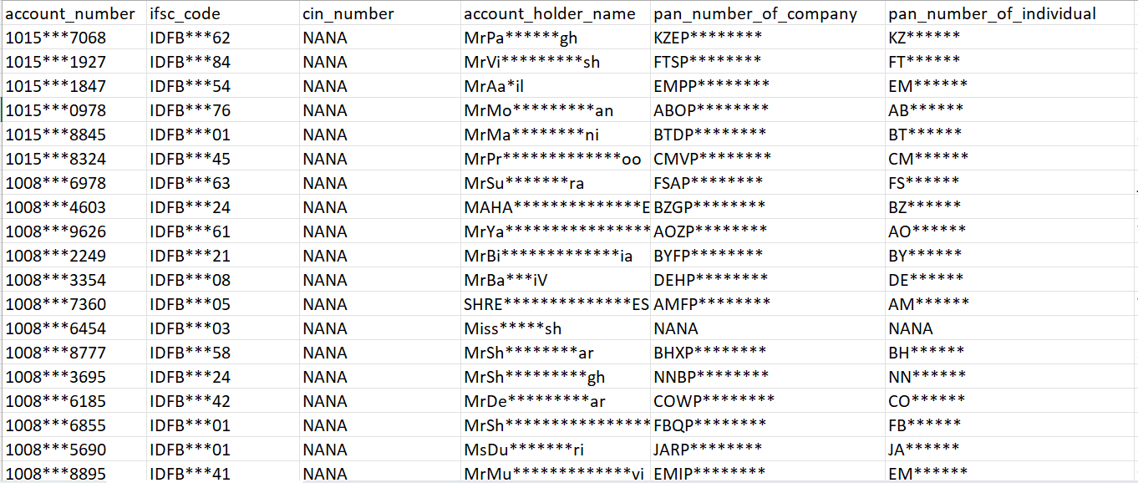

Processed data-

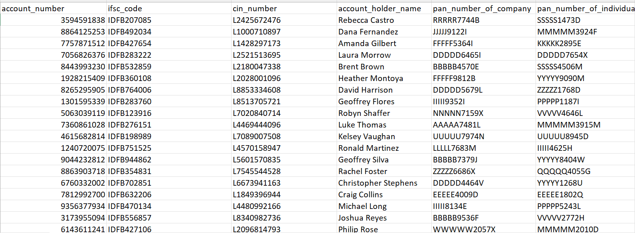

**1.3.1.2 Designed basic framework of dashboard with the provided graphs**

**summary:**

* **Task:** To design a basic interactive dashboard framework for visualizing and analysing suspect registry data with Excel data.
* **Implementation:**
* Developed a Streamlit-based dashboard for quick deployment and interactivity.
* Structured the layout to include key sections: Total Records, Unique Banks, and Unique Sources as headline KPIs.
* Section headers for: Unique Records Count, Market Overview, Records by Source, Records by Bank, Top Contributing Banks, Horizontal chart, Scorecard view, Added placeholders for relevant Plotly charts, allowing easy integration later.
* **Outcome:**

Delivered a visually clean and organized dashboard layout. Included all necessary metrics and graph placeholders, ensuring easy extensibility. Ready for integration with real-time data from Excel or database sources.

Framework serves as a foundation for full interactivity and analysis features such as filtering, sorting, and deep dives per suspect detail.

* **Screenshots:**

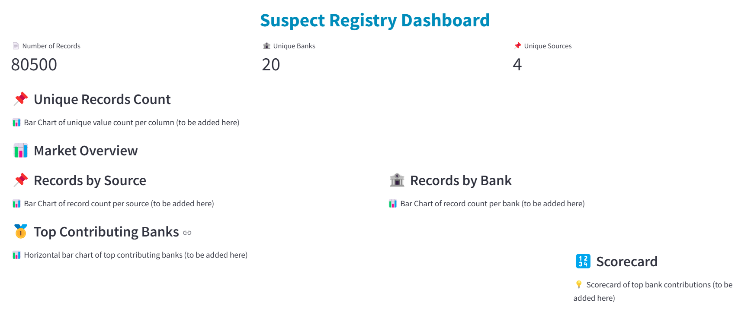

**1.3.1.3 developed Unique Field Analysis for key Attributes:**

* **Task:**  
  To analyze the most frequently occurring entries across important fields like phone numbers, IFSC codes, account numbers, and email IDs.
* **Implementation:**  
  Used Pandas and Streamlit to compute and display the most repeated values using bar charts and tables. Integrated filters to dynamically view data frequency based on field selection.
* **Outcome:**  
  Identified suspiciously recurring values in sensitive fields, which can be used for further investigation of fraudulent patterns or linked suspects.
* **Screenshot:**

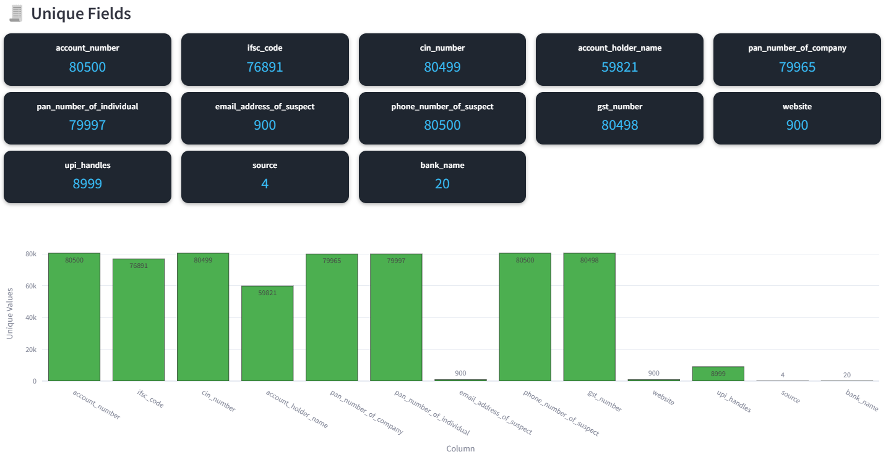

**1.3.1.4 Built Visual Insights of Records by bank and source:**

* **Task:**  
  To visualize how data is distributed by bank and source to understand data origin patterns.
* **Implementation:**  
  Grouped data using Pandas and plotted results using Streamlit's st.bar_chart() and plotly.express for more detailed interactive graphs.
* **Outcome:**  
  Provided clear insights on which banks and sources are contributing the most entries, enabling better targeting of investigation efforts.
* **Screenshot:**

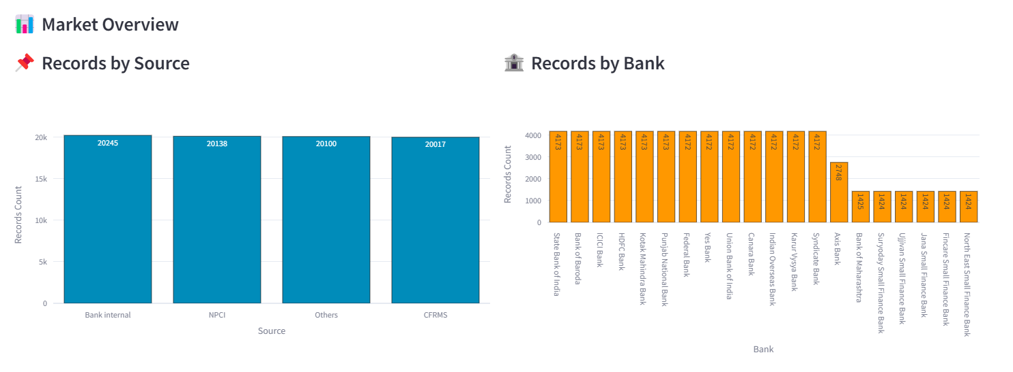

**1.3.1.5 Integrated Date Filtering and Top Contributor Detection**

* Task:  
  To enable filtering of records by specific date ranges and detect top contributors within those periods.
* Implementation:  
  Implemented Streamlit's date range picker and filtered DataFrames accordingly. Used value_counts() and groupby() methods to rank contributors by volume.
* Outcome:  
  Enhanced the dashboard's ability to zoom into specific timeframes and identify which accounts or entities were most active or suspicious.
* Screenshot:

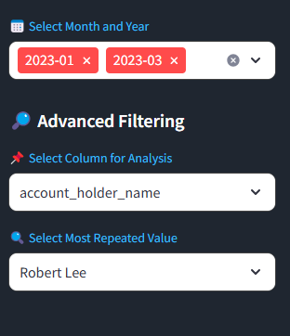

**1.3.1.6 Final Dashboard Styling, Optimization, and Testing**

* **Task:**To allow investigators to narrow down results based on specific account numbers, contact details, or field values.
* **Implementation:**  
  Added multi-select and search filters for fields like account number, mobile number, and email. Used conditional filtering logic to refresh visualizations dynamically.
* **Outcome:**Empowered users to dig into focused areas of the data, speeding up pattern detection and improving efficiency in linking suspects.
* **Screenshots:**

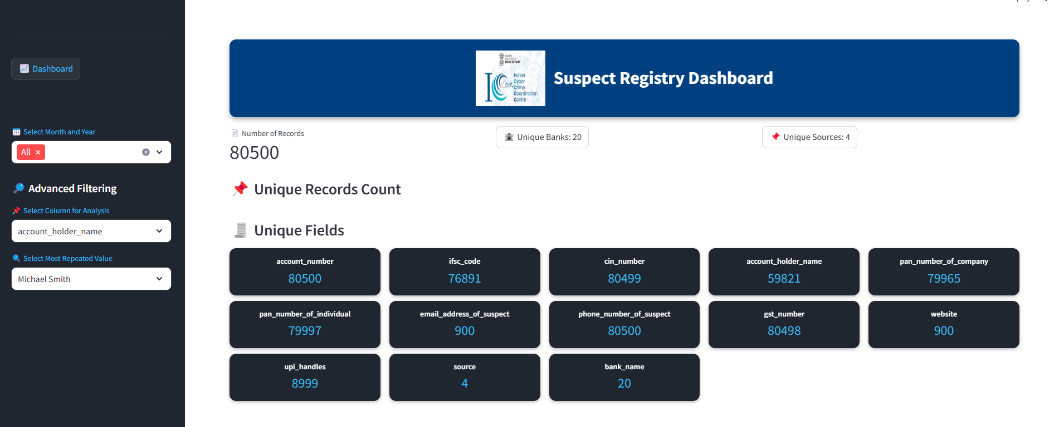

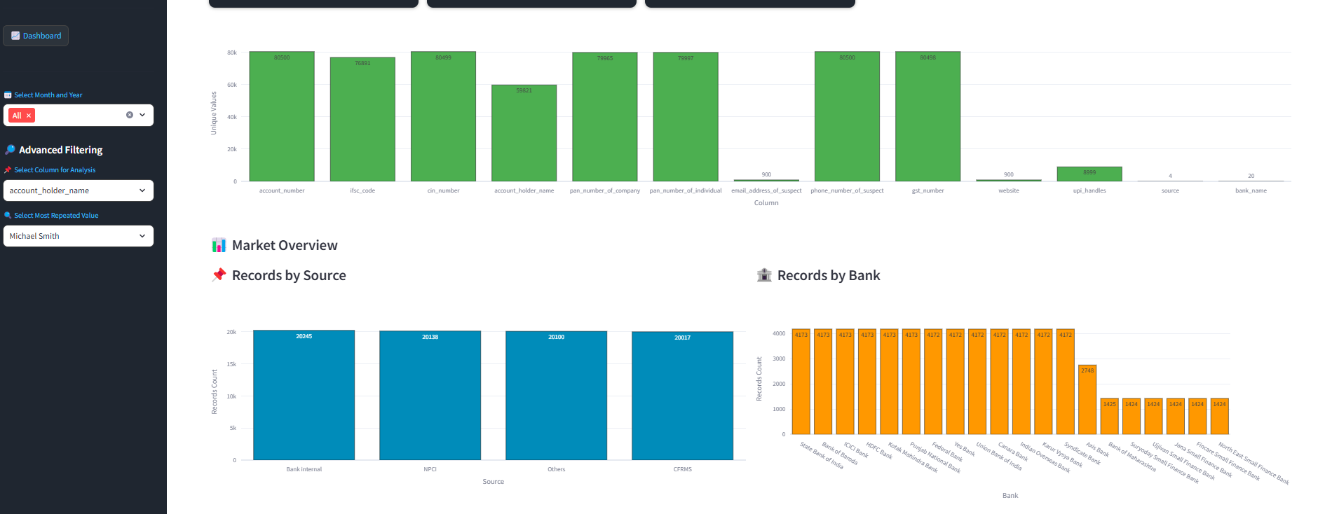

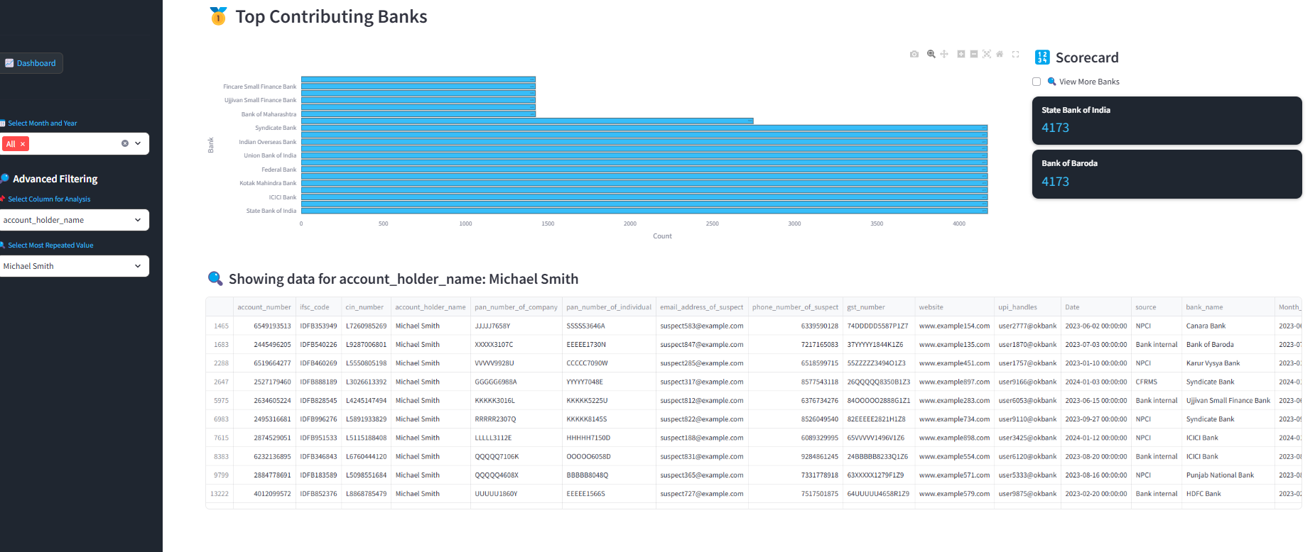

**1.3.2 Analyse data, SQL Integration and Query execution:**

* **Task:** To develop a functional Database Search System that allows users to query and retrieve suspect data based on different categories using SQL integration.
* **Screenshots:**

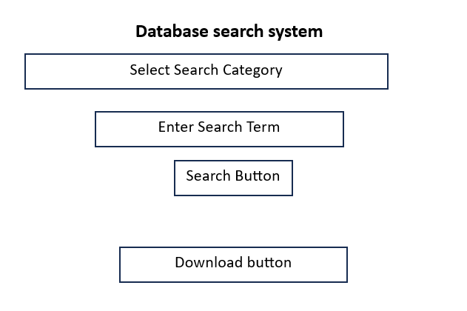

**1.3.2.1 Database Creation and Management:**

* **Task:** Design and manage the database schema using SQLite  
  **Implementation:**
* Used DB Browser to create the new_suspect_file2.db file.
* Structured the database with normalized tables for suspect records (e.g., account number, IFSC, PAN, CIN, email, phone, GST).
* Ensured no redundant data or anomalies during data insertion.
* **Outcome:**  
  A clean, normalized SQLite database ready for backend operations and GUI search integrations.
* **Screenshot:**

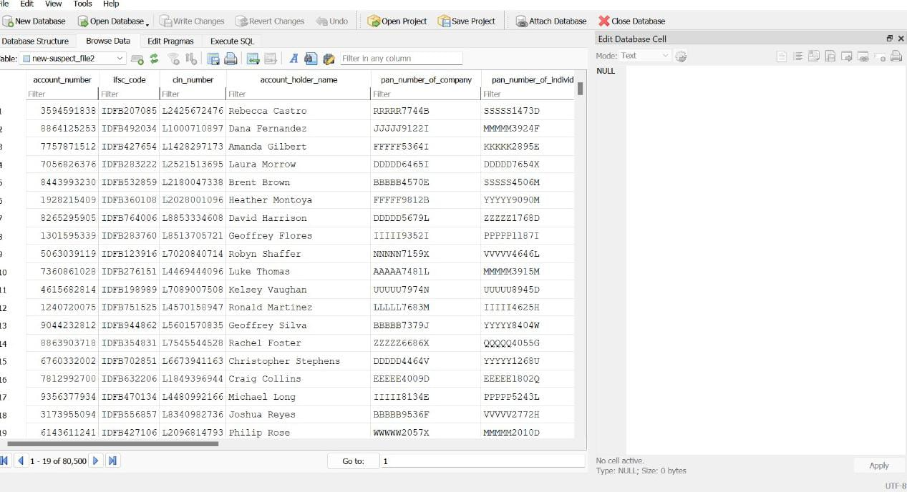

**1.3.2.2 CSV Data Import and Integration with SQLite:**

* **Task:** Import raw data from a CSV into SQLite and integrate it with Python  
  **Implementation:**
* CSV file imported via pandas.read_csv() with empty values filled.
* Data viewed, verified, and optionally synced with the SQLite database.
* Used Pandas for CSV processing, maintaining consistency and fast loading.
* **Outcome:**  
  CSV successfully read and integrated, enabling flexible searching and export through the GUI.

**Screenshots:**

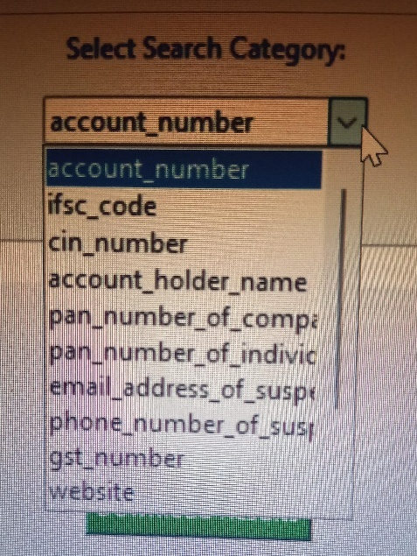

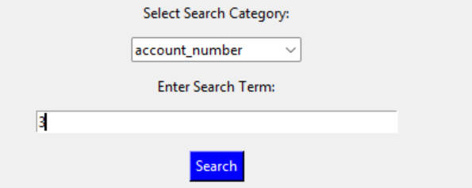

**1.3.2.3 Search System Implementation (GUI):**

* **Task:** Create a user-friendly search interface to query suspect data  
  **Implementation:**
* Built GUI using with dropdown to select search category and input field for query.
* Implemented a responsive search button linked to the backend filter logic.
* **Outcome:**  
  A working interface where users can search data by any field (e.g., phone number, email, GST) with results displayed instantly.

**Screenshots:**

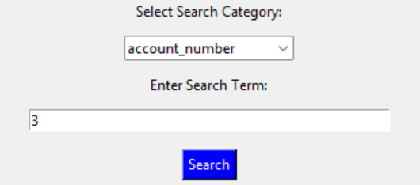

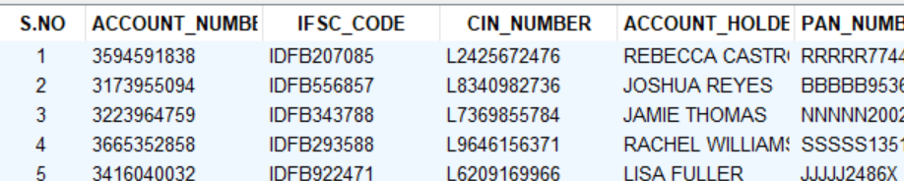

**1.3.2.4 Dynamic Query Filtering:**

* **Task:** Implement flexible and case-insensitive filtering based on selected category
* **Implementation:**
* Used .str.contains() in Pandas with .lower() to ensure case-insensitive searches.
* Filtered dataset stored in a global filtered_data variable for display/export.
* **Outcome:**  
  Users can input partial or full search terms and get accurate, dynamically filtered results.
* **Screenshots:**

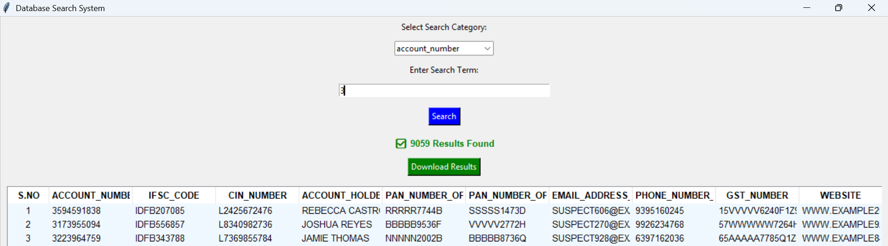

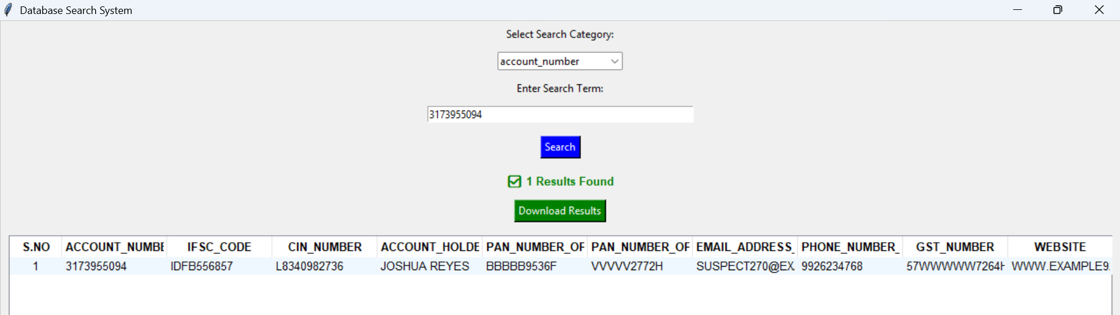

**1.3.2.5 Result Count and Feedback Display:**

* **Task:** Inform users of search results status
* **Implementation:**

After each search, display either ✅ <count> Results Found or ❌ No Results Found using Label.

Used conditional formatting (green/red) to distinguish success or no results.

* **Outcome:**  
  Users receive immediate feedback on whether their query returned matches, improving UX clarity.
* **Screenshots:**

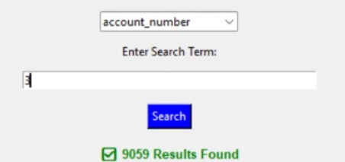

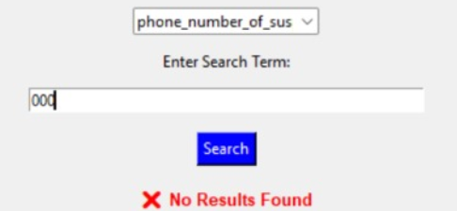

**1.3.2.6 CSV Export of Filtered Results:**

* **Task:** Allow exporting of search results
* **Implementation:**

Integrated filedialog ask save as filename() for file location selection.

Exported filtered data using Data Frame to csv() with serial numbering added.

* **Outcome:**  
  Filtered data can be saved locally by users in CSV format, useful for offline reporting or record-keeping.
* **Screenshots:**

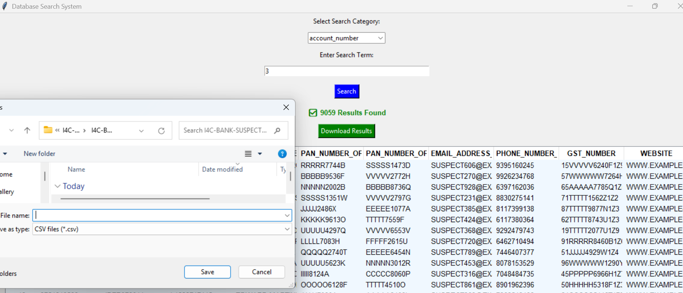

**1.3.2.7 Backend Error Handling and Optimization:**

* **Task:** Optimize code and ensure reliability  
  **Implementation:**
* Used exception handling (try-except indirectly where needed).
* Avoided nested loops, reused variables, and filtered columns efficiently.
* Used .fillna("") to prevent search errors due to NaNs.
* **Outcome:**  
  The backend remains stable even with incorrect input or empty fields, avoiding crashes or silent failures.

**1.3.2.8 GUI Design and User Experience (UX):**

* **Task:** Ensure a clean, readable, and efficient interface
* **Implementation:**
* Added bold column headers with Tree view, Heading style.
* Applied background highlight for rows and properly spaced components.
* Used fixed column widths and scroll-friendly design.
* **Outcome:**  
  Professional and neat interface where users can scroll, read, and interact with the data easily.
* **Screenshots:**

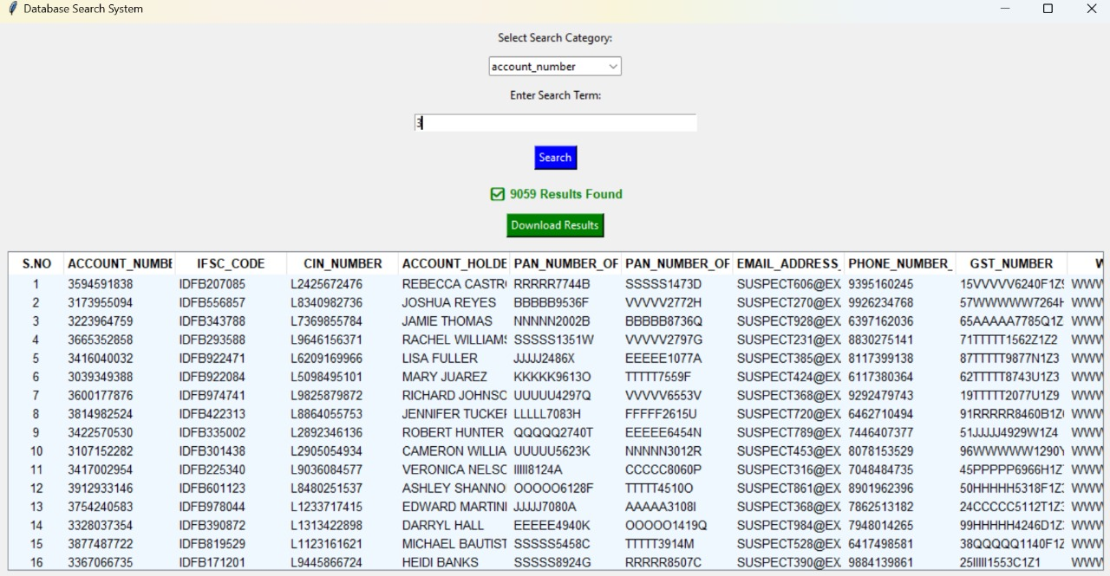

**Learning Outcomes:**

The development of the **Suspect Registry Dashboard** was a highly enriching experience that provided valuable insights into various technical and practical aspects of software development. Through this project, I gained hands-on experience in **database management, backend development, security implementation, UI/UX design, and data analytics**, which are crucial in real-world applications.

* **Database Management and Query Optimization**
  + Learned to design an **efficient and normalized database schema** to store and manage suspect records securely.
  + Gained experience in **SQL query optimization**.
  + Understood the importance of **scalability** by ensuring that the database structure could transition from SQLite.
* **Advanced Search and Filtering Mechanisms**
  + Developed **dynamic search functionality** with advanced filtering based on multiple parameters (e.g., age, crime category, location).
* **Data Visualization and Analytical Thinking**
  + Used **Plotly and Matplotlib** to create **interactive charts, graphs, and heatmaps**, transforming raw data into insightful visual reports.
  + Understood the importance of **crime trend analysis** and how visual data representation helps in decision-making.
  + Developed the ability to **extract meaningful patterns** from datasets, improving problem-solving skills.
* **UI/UX and Frontend Development**
  + Learned to develop an intuitive, interactive UI using **Streamlit**, making the dashboard user-friendly for law enforcement officers.
  + Improved **UI design skills**, including layout optimization, **dark mode implementation**, and enhancing readability.
  + Understood the importance of **accessibility and user-centric design**, ensuring the dashboard was easy to navigate.
* **Performance Optimization and Scalability**
  + Applied **lazy loading and pagination techniques** to handle large datasets efficiently.
  + Ensured that the system was designed to **scale** with increasing data loads without affecting performance.
  + Gained knowledge about **server-side optimizations** and **efficient memory management** to improve response times.
* **Testing**
  + Conducted extensive **unit testing and integration testing** using **Pytest** to ensure system reliability.

**Tools and Technologies used:**

|  |  |  |
| --- | --- | --- |
| **S.no** | **Tool/Technology used** | **Purpose** |
| **1** | Python | Backend scripting and data processing |
| **2** | SQL | Database management for suspect registry data |
| **3** | Streamlit | Interactive dashboard creation and visualization |
| **4** | Pandas | Data analysis and preprocessing |
| **5** | Plotly | Creating interactive graphs and charts |
| **6** | NumPy | Mathematical operations and data manipulation |
| **7** | Matplotlib & Seaborn | Statistical visualization for suspect data |
| **8** | Excel & CSV Handling | Managing structured data imports and exports |
| **9** | Data Masking Techniques | Protecting sensitive suspect registry information |

**Challenges Faced:**

1. **Database Management Issues**
   * Ensuring efficient queries and indexing for large datasets.
   * Handling database locks when multiple users update records simultaneously.
   * Managing database schema changes without data loss.
2. **Data Entry and Validation**
   * Preventing duplicate entries or incorrect suspect information.
   * Implementing input validation for fields like age, crime category, and case status.
3. **Performance Bottlenecks**
   * Slow dashboard response due to heavy database queries.
   * Large datasets causing high memory usage in Streamlit.
   * Optimizing queries to fetch only relevant data instead of loading everything at once.
4. **User Authentication & Security**
   * Ensuring unauthorized users cannot access or modify records.
   * Implementing a login system (e.g., Firebase or hashed password authentication).
   * Protecting against SQL injection and other security threats.
5. **Dynamic Filtering & Search Implementation**
   * Making real-time search smooth without lag.
   * Efficiently filtering based on multiple criteria like name, crime type, and status.
6. **Visualization Challenges**
   * Choosing the best charts to display crime trends effectively.
   * Handling missing or incomplete data in visualizations.

**Contribution:**

**Contributions to the Suspect Registry Dashboard**

* The Suspect Registry Dashboard is a robust and comprehensive application designed to efficiently manage, analyse, and visualize criminal data. My extensive contributions to this project encompassed several critical areas, including database development, backend programming, user authentication, UI/UX design, advanced search functionalities, data visualization, security measures, and performance optimization. The overarching goal was to provide law enforcement agencies with a seamless, data-driven platform to store, retrieve, and analyse suspect-related information, ensuring more efficient criminal investigations and better decision-making processes.

**Database Development and Optimization**

* A key part of my contributions involved designing and developing an optimized SQLite database to securely store and manage suspect records. I structured the database schema to include essential fields. By implementing data normalization, I minimized redundancy and ensured efficient data organization.

**UI/UX Enhancements for an Intuitive Experience**

* A user-friendly interface was essential for efficient interaction with large datasets. To achieve this, I developed the frontend using Streamlit, which provided an interactive, web-based UI. I incorporated CSS styling to enhance readability and added a dark mode option to improve usability, especially for officers working at night.
* Navigation was carefully structured to include dynamic search filters, quick-access menus, and an intuitive dashboard layout that displayed real-time statistics, recent case updates, and suspect profiles. The UI was designed for optimal efficiency, enabling users to locate relevant information quickly and without unnecessary complexity.

**Advanced Search and Filtering System**

* To facilitate efficient suspect retrieval, I implemented an advanced filtering system that allowed users to refine searches based on multiple criteria, such as crime category, age range, location, and case status. By leveraging SQL indexing and optimized search algorithms, search results were generated with minimal delay, even for large datasets.

.

**Data Visualization Analytics**

* To provide law enforcement teams with actionable insights, I incorporated **interactive data visualizations** using **Plotly and Matplotlib**. These visual elements transformed the registry from a mere data repository into a powerful analytical tool. The dashboard featured:
* **Bar graphs** illustrating suspect arrests by region.

By offering these analytical tools, I enabled law enforcement agencies to identify trends, allocate resources effectively, and enhance crime prevention strategies

**Conclusion:**

The **Suspect Registry Dashboard** is a robust and comprehensive solution designed to enhance law enforcement's ability to manage and analyse criminal data efficiently. This project successfully integrates **database management, security protocols, user authentication, advanced search mechanisms, and data visualization** into a seamless platform that aids in criminal investigations. By leveraging modern technologies such as **SQLite, Streamlit, Plotly, and advanced search algorithms**, the dashboard provides an intuitive interface for officers to access and analyse suspect-related information quickly and accurately.